Object Oriented Programming
Micro Project Report on

FOOD ORDERING SYSTEM
Under The Guidance Of
K. SRIVIDYA
By
M. Tejasri –1602-20-748-054
M. Vaishnavi –1602-20-748-056


Department of Computer Science & Engineering
Vasavi College of Engineering (Autonomous)
(Affiliated to Osmania University)
Ibrahimbagh, Hyderabad-31
2021-22
Vasavi College of Engineering (Autonomous)
(Affiliated to Osmania University)
Hyderabad-500 031
Department of Computer Science & Engineering
DECLARATION BY THE CANDIDATE
We, M.Tejasri and M.Vaishnavi bearing hall ticket number, 1602-20-748-054&056, hereby declare that the project report entitled Food Ordering System Department of Computer Science & Engineering, VCE, Hyderabad, is submitted in partial fulfilment of the requirement for the award of the degree of Bachelor of Engineering in Computer Science & Engineering.
This is a record of bonafide work carried out by me and the results embodied in this project report have not been submitted to any other university or institute for the award of any other degree or diploma.
M. Tejasri (1602-20-748-054)
M. Vaishnavi (1602-20-748-056)

Vasavi College of Engineering (Autonomous)
(Affiliated to Osmania University)
Hyderabad-500 031
Department of Computer Science & Engineering
BONAFIDE CERTIFICATE
This is to certify that the project entitled FOOD ORDERING SYSTEM being submitted by M. Tejasri and M. Vaishnavi, bearing 1602-20-748-054&056, in partial fulfilment of the requirements for the award of the degree of Bachelor of Engineering in Computer Science & Engineering is a record of bonafide work carried out by him/her under my guidance

K. SRIVIDYA, Dr. T. Adilakshmi ,
Assistant Professor, Professor & HOD,
Internal Guide. Dept. of CSE.

ACKNOWLEDGEMENT
The satisfaction and euphoria that accompanies the successful completion of any task would be incomplete without the mention of the people made it possible and whose encouragement and guidance have made our efforts with success.
We are indebted to the Internal Guide, K. Sri Vidhya, ASSISTANT PROFESSOR, Computer Science & Engineering, VASAVI COLLEGE OF ENGINEERING, Ibrahimbagh, hyd-31 for her support and guidance throughout the project.
We are also indebted to the Head of the Department, Dr. T. Adilakshmi, PROFESSOR, Computer Science and Engineering, VASAVI COLLEGE OF ENGINEERING, Ibrahimbagh, hyd-31 for her support and guidance throughout the project.
We extend our deep sense of gratitude to the Principal, S. V. RAMANA RAO, VASAVI COLLEGE OF ENGINEERING, Ibrahimbagh, hyd-31 permitting us to undertake this project.

TABLE OF CONTENTS

S.No. | Contents | Page no.
1 | Abstract | 5
2 | Introduction | 6
3 | Methods used | 7
4 | Hardware Specifications | 8
5 | Software Specifications | 8
6 | Sample Code | 9-16
7 | Output | 17-18
8 | References | 19

ABSTRACT
ONLINE FOOD ORDERING SYSTEM ABSTRACT The online food ordering system provides convenience for the customers. It overcomes the disadvantages of the traditional queuing system. This system increases the takeaway of foods than visitors. Therefore, this system enhances the speed and standardization of taking the order from the customer. It provides a better communication platform. The user’s details are noted electronically. The online food ordering system set up menu online and the customers easily places the order with a simple mouse click. Also with a food menu online you can easily track the orders, maintain customer's database and improve your food delivery service. This system allows the user to select the desired food items from the displayed menu. The user orders the food items. The payment can be made online or pay-on-delivery system. The user’s details are maintained confidential because it maintains a separate account for each user. An id and password is provided for each user. Therefore it provides a more secured ordering.

INTRODUCTION
Online Food ordering system is a process in which one can order various foods and beverages from some local restaurant and hotels through the use of internet, just by sitting at home or any place. And the order is delivered to the told location.
Nowadays everyone is having busy schedule whether it is urban area or rural. But talking specifically about the urban areas and deeply about the big cities, people out there are so busy in their life that they don’t get enough of time to have their meals properly.
So food ordering system these days has one of the fastest growing market, though being a new idea. In this project we have developed something like the same to earn from and serve the nation in a much better way possible.
It overcomes the demerits of the manual hotel or mess system and the old fashioned queuing system. This system enhances the readymade of foods than people.
Therefore, this system enhances the speed of getting food in person’s plate and quality and manner of taking the order from the customer. It provides a better communication platform. The user’s details are stored using the electronic media.
The online food ordering system provides the menu online and the customers can easily place the order by just clicking the mouse or by touching a button on their smart phones.

Methods Used
Classes:
Administrator class
Customer class
Manager class
Customer class
This class provided:
⦁ View product’s list
⦁ Register
⦁ Place orders
Manager class
This class provided:
⦁ Create product categories and functionalities,
⦁ Edit / delete product categories and descriptions,
⦁ View and manage orders and sales report,
Administrator class
This module is used to create usernames and passwords by admin. Admin can view all the information about the user or delete or edit the all details about the manager and customer.

Hardware specifications
• Hardware – Pentium
• Speed – 1.1 GHz
• RAM – 1GB
• Hard Disk – 20 GB
• Floppy Drive – 1.44 MB
• Key Board – Standard Windows Keyboard
• Mouse – Two or Three Button Mouse
• Monitor – SVGA
Software requirements
• Operating System: Windows
• Web Technologies : Html, JavaScript, CSS
Source Code
package food;
import java.awt.event.ActionEvent;
import java.awt.event.ActionListener;
import java.io.File;
import java.io.FileReader;
import java.io.FileWriter;
import java.io.IOException;

import javax.swing.*;

public class Food implements ActionListener
{

public static void main(String args[]) {

JFrame f=new JFrame("ONLINE FOOD");
JLabel l1=new JLabel("Login");
l1.setBounds(50,50,150,20);
JTextField tf1=new JTextField();
tf1.setBounds(250,50, 150,20);
JLabel l2=new JLabel("Password");
l2.setBounds(50,100,150,20);
JPasswordField tf2=new JPasswordField();
tf2.setBounds(250,100, 150,20);
JButton b=new JButton("Submit");
b.setBounds(300,150,150,20);
b.addActionListener(new ActionListener(){
@SuppressWarnings("deprecation")

public void actionPerformed(ActionEvent e){

if(tf1.getText().equals("hi") && tf2.getText().equals("bye"))
{

File fin=new File("file.txt");

JMenu menu;
JMenuItem i1, i2, i3;
JFrame f= new JFrame("FOOD ORDERING");
JMenuBar mb=new JMenuBar();
menu=new JMenu("Menu");
i1=new JMenuItem("view total orders");
i2=new JMenuItem("clear order details");
i3=new JMenuItem("amount");
menu.add(i1);
menu.add(i2);
menu.add(i3);
mb.add(menu);
f.setJMenuBar(mb);
f.setSize(400,400);
f.setVisible(true);
JLabel a=new JLabel("...... MENU ......");
a.setBounds(600,20,250,50);
f.add(a);
JLabel p=new JLabel("RUMALIROTI");
p.setBounds(50,100,150,20);
JTextField p1=new JTextField("0");
p1.setBounds(250, 100, 100, 20);
JLabel e1=new JLabel("20/- each");
e1.setBounds(400,100,100,20);
f.add(p);
f.add(p1);
f.add(e1);
JLabel k=new JLabel("VEG RECIEPES");
k.setBounds(200, 50, 100, 40);
JLabel i=new JLabel("PANEER BUTTER");
i.setBounds(50,150,150,20);
JTextField q1=new JTextField("0");
q1.setBounds(250, 150, 100, 20);
JLabel e2=new JLabel("150/- each");
e2.setBounds(400,150,100,20);
f.add(k);
f.add(i);
f.add(q1);
f.add(e2);
JLabel d=new JLabel("VEGBIRYANI");
d.setBounds(50,200,150,20);
JTextField d1=new JTextField("0");
d1.setBounds(250, 200, 100, 20);
JLabel e3=new JLabel("200/- each");
e3.setBounds(400,200,100,20);
JLabel a1=new JLabel("STARTERS");
a1.setBounds(900,50,100,40);
JLabel a2=new JLabel("MANCHURIA");
a2.setBounds(800,100,150,20);
JTextField a3=new JTextField("0");
a3.setBounds(900, 100, 100, 20);
JLabel a4=new JLabel("150/- each");
a4.setBounds(1050,100,150,20);
JLabel a5=new JLabel("TOMATO SOUP");
a5.setBounds(800,150,150,20);
JTextField a6=new JTextField("0");
a6.setBounds(900, 150, 100, 20);
JLabel a7=new JLabel("120/- each");
a7.setBounds(1050,150,150,20);
f.add(a1);
f.add(e2);
f.add(a2);
f.add(a3);
f.add(a4);
f.add(a5);
f.add(a6);
f.add(a7);
f.add(d);
f.add(d1);
f.add(e3);
f.setLayout(null);
JButton be=new JButton("SUBMIT");
be.setBounds(350, 300, 100, 20);
f.add(be);
be.addActionListener(new ActionListener(){

public void actionPerformed(ActionEvent e)

{

if(e.getSource()==be)
{

try
{
if(!fin.exists())

{

fin.createNewFile();

}
FileWriter fout=new FileWriter(fin.getAbsoluteFile(),true);
int v1=Integer.parseInt(p1.getText());
int v2=Integer.parseInt(q1.getText());
int v3=Integer.parseInt(d1.getText());
int v4=Integer.parseInt(a3.getText());
int v5=Integer.parseInt(a6.getText());
int total=(20*v1)+(150*v2)+(200*v3)+(v4*150)+(v5*120);

String a="Rumali roti :"+v1+"\n"+"Panner butter masala :"+v2+"\n"+"Veg Biryani :"+v3+"\n"
+"Manchuria :"+v4+"\n"+"Tomato Soup :"+v5+"\n"+"TOTAL : "+total+"\n"+"------------------------------\n";

fout.write(a);
String t3=String.valueOf(total);
JTextField fd=new JTextField();
JLabel to=new JLabel("total amount to be paid");
to.setBounds(50, 400,150,20);
f.add(to);
fd.setBounds(500, 400, 150, 40);
fd.setText(t3);
f.add(fd);
fout.close();
}
catch (IOException e1) {
e1.printStackTrace();
}
}
}
});
i1.addActionListener(new ActionListener() {
public void actionPerformed(ActionEvent eq)
{
if(eq.getSource()==i1)

{

try

{

FileReader fin1=new FileReader("file.txt");
JFrame f3=new JFrame();
f3.setSize(400, 400);
JTextArea a2=new JTextArea();
a2.setSize(1900, 1900);
f3.add(a2);
int i,p=0;
char lov[]=new char[10000];
while((i=fin1.read())!=-1){
lov[p]=(char)i;
p++;

}
fin1.close();
String str=new String(lov);
a2.setText(str);
f3.setLayout(null);
f3.setVisible(true);
}catch(Exception e)

{
JFrame fd2=new JFrame();
JOptionPane.showMessageDialog(fd2,"THERE IS NO RECORD PRESENT. EMPTY RECORD","MESSAGE",JOptionPane.INFORMATION_MESSAGE);

}
}
}
});
i2.addActionListener(new ActionListener()
{
public void actionPerformed(ActionEvent e)
{
JFrame fd=new JFrame();
JOptionPane.showMessageDialog(fd,"Successfully removed.","Alert",JOptionPane.CANCEL_OPTION);
File f1=new File("C:\\Users\\DELL\\eclipse-clg\\food\\file.txt");
f1.delete();
}
});
i3.addActionListener(new ActionListener()
{
public void actionPerformed(ActionEvent mi)
{
int v1=Integer.parseInt(p1.getText());
int v2=Integer.parseInt(q1.getText());
int v3=Integer.parseInt(d1.getText());
int v4=Integer.parseInt(a3.getText());
int v5=Integer.parseInt(a6.getText());
int total=(20*v1)+(150*v2)+(200*v3)+(v4*150)+(v5*120);
JFrame fd=new JFrame()

JOptionPane.showMessageDialog(fd,"total amount to be paid :"+total,"BILL",JOptionPane.INFORMATION_MESSAGE);

}

});
}

else
{
JLabel l1=new JLabel("INVALID CREDENTIALS");
l1.setBounds(400, 150, 300, 50);
f.add(l1);
}
}
});

f.add(l1);f.add(l2);f.add(tf1);f.add(tf2);f.add(b);
f.setLayout(null);
f.setSize(600,600);
f.setVisible(true);
f.setDefaultCloseOperation(JFrame.EXIT_ON_CLOSE);
}

@Override
public void actionPerformed(ActionEvent e) {
// TODO Auto-generated method stub

}

}
Test Cases
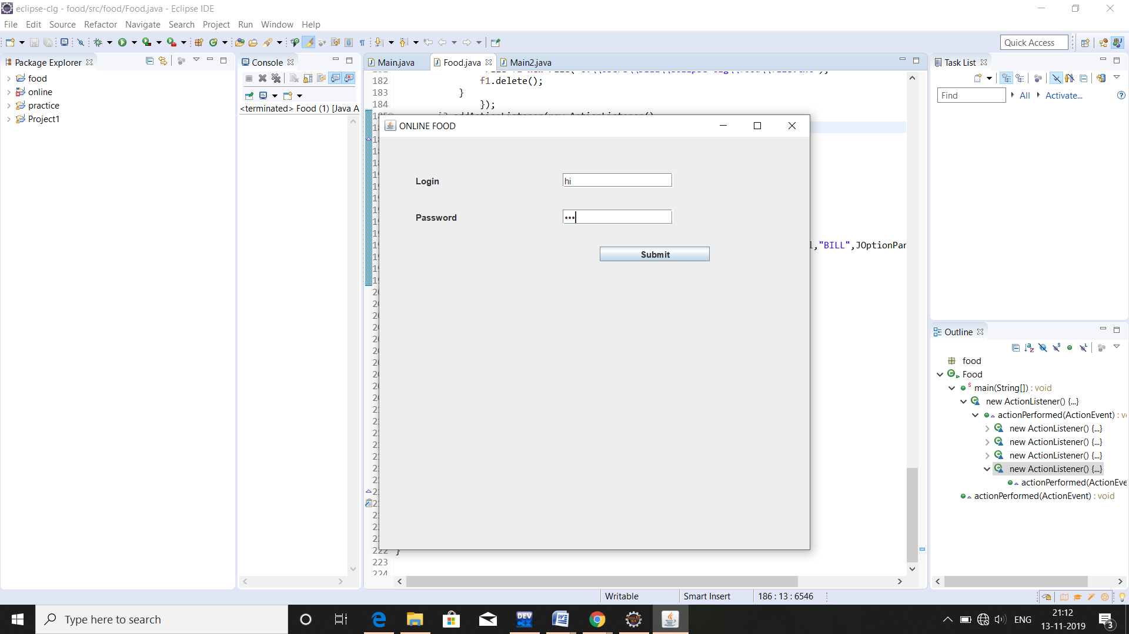
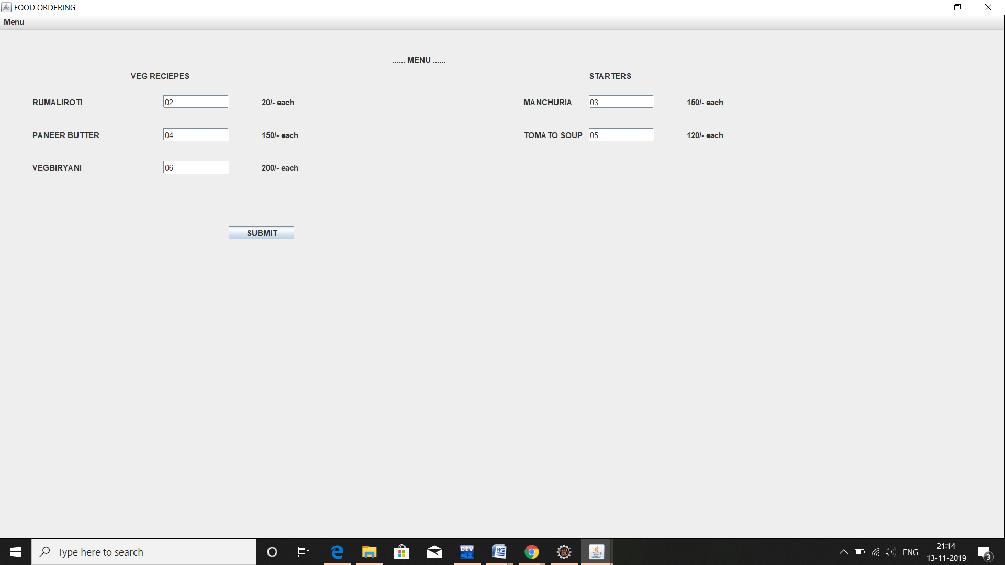
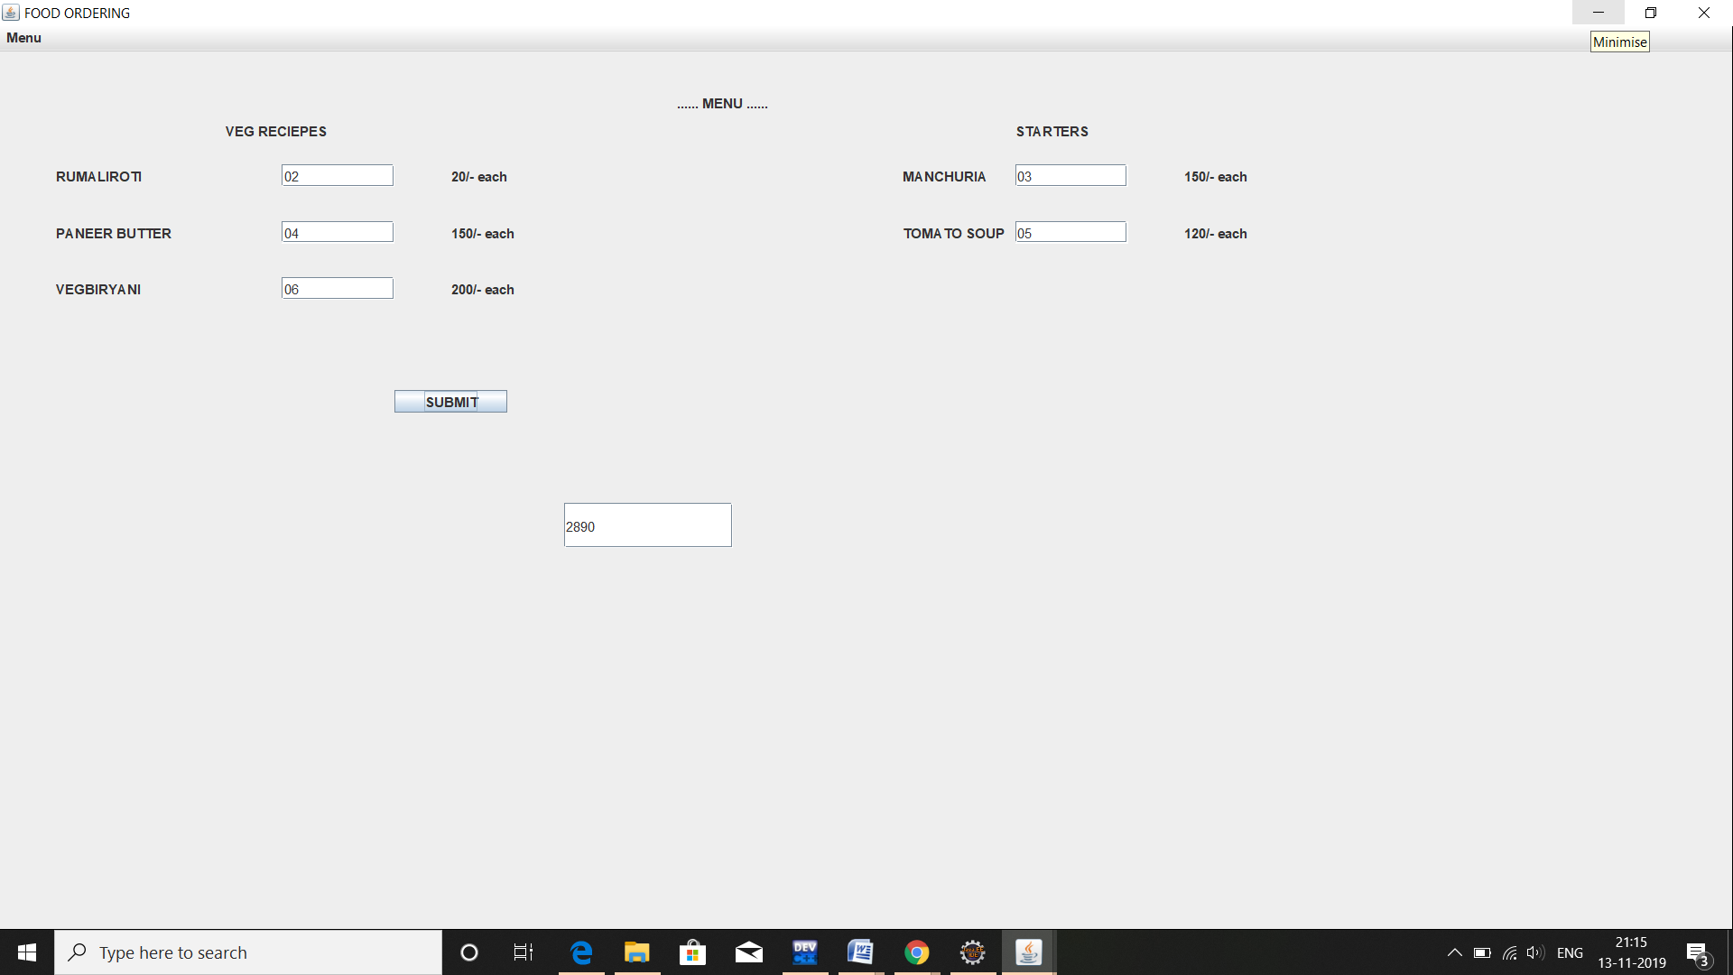
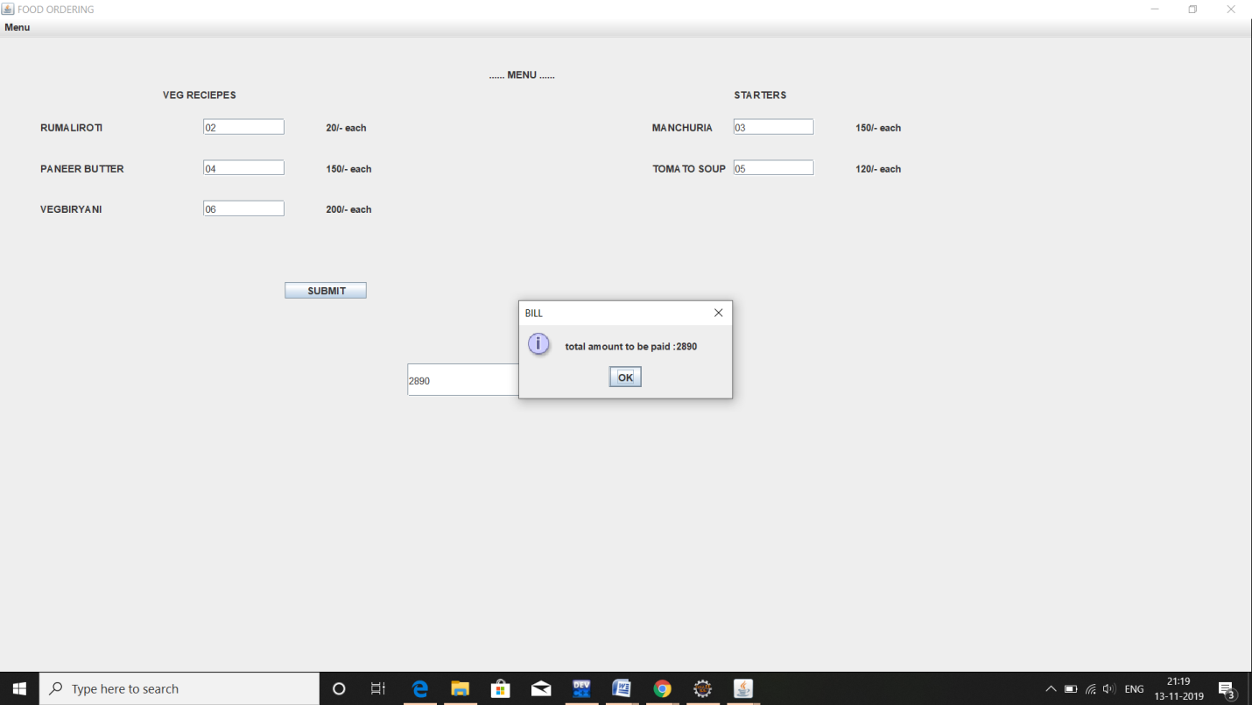
References:
1.https://www.youtube.com/watch?v=oepmLGQP1m4&list=PLUoqTnNH2Xz_BUrjcahKWDhPcUj-FTOt
2. http://www.javazoom.net/jzservlets/uploadbean/uploadbean.html
3. https://javabrains.io/
4. http://www.java2s.com/Tutorial/Java/0360__JSP/JSPDummyShoppingCart.htm

